Program Information | [Lesson Title]  Linear Connections |  |  |  |  |  | TEACHER NAME |  |  |  | PROGRAM NAME
Program Information | [Unit Title] |  |  |  |  |  | NRS EFL(s)  4 |  |  |  | TIME FRAME  120 minutes
Instruction | ABE/ASE Standards – Mathematics
Instruction | Numbers (N) |  |  | Algebra (A) |  | Geometry (G) |  |  |  | Data (D)
Instruction | Numbers and Operation |  |  | Operations and Algebraic Thinking |  | Geometric Shapes and Figures |  |  |  | Measurement and Data
Instruction | The Number System |  |  | Expressions and Equations | A.4.9 | Congruence |  |  |  | Statistics and Probability
Instruction | Ratios and Proportional Relationships |  |  | Functions | A.4.12, A.4.13, A.4.15, A.4.14 | Similarity, Right Triangles. And Trigonometry |  |  |  | Benchmarks identified in RED are priority benchmarks. To view a complete list of priority benchmarks and related Ohio Aspire lesson plans, please see the Curriculum Alignments located on the Teacher Resource Center (TRC).
Instruction | Number and Quantity |  |  |  |  | Geometric Measurement and Dimensions
Instruction |  |  |  |  |  | Modeling with Geometry
Instruction | Mathematical Practices (MP)
Instruction | □ | Make sense of problems and persevere in solving them. (MP.1) |  |  |  | □ |  | Use appropriate tools strategically. (MP51)
Instruction | □ | Reason abstractly and quantitatively. (MP.2) |  |  |  | □ |  | Attend to precision. (MP.6)
Instruction | □ | Construct viable arguments and critique the reasoning of others. (MP.3) |  |  |  | □ |  | Look for and make use of structure. (MP.7)
Instruction | ☑ | Model with mathematics. (MP.4) |  |  |  | □ |  | Look for and express regularity in repeated reasoning. (MP.8)
Instruction | LEARNER OUTCOME(S)  Students will take everyday situations and create linear equations. Students will solve linear equations.  Students will create graphs using data from contextual situations. |  |  |  |  |  | ASSESSMENT TOOLS/METHODS  Assessment/Evidence (based on outcome)  Parts 2, 4, 5, and 6 will provide evidence of students’ understanding and mastery of the concepts. During part 5, the teacher should look and listen for signs of understanding and misconceptions that students may have.
Instruction | LEARNER PRIOR KNOWLEDGE  Students should be able to plot points on an X-Y plane, translate word problems into linear equations, solve algebraic equations, and have a basic concept of slope.
Instruction | INSTRUCTIONAL ACTIVITIES  Part 1: (I do)  To start the lesson, write the three main forms of linear equations on the board, with their generic formula, and an example (see Teacher Answer Sheet). Then go through the steps of graphing each example. Start with the Standard Form example and create a t-table to list possible points.  The easiest way to solve for two points is to plug in a 0 for x and solve for y (you get the point (0,2)) and 0 in for y and solve for x (you get the point (3,0)).  Plotting the two points on a coordinate plane and connecting the dots will create the graphical representation of the equation of the line.  It may be a good idea to give further information about the particular points we found. When we plug in 0 for x and solve for y, the point we find is known as the y-intercept since it crosses the y-axis there. If we plug 0 in for y and solve for x, we get the x-intercept as that is where the graph crosses the x-axis. Choose two other points on the line, say (−3,4) and (9, −4), to demonstrate that all points on the line are solutions to the equation. Moving to the Point-Slope Form example, right from the equation, we know the point (−1,3) is a point on the line as the x is added by 1 (or subtracted by -1) and the y is subtracted by 3. Also, since the slope is 2, which can be written as 2/1 to display rise-over- run, our next point can be found by going up two and right one. Connecting the points with a line will be the graphical representation of the equation.  Again, choose two other points to demonstrate that all points on the line are solutions to the equation. For the Slope- Intercept Form example, since the constant term is -1, we know the y-intercept is the point (0, −1) and the slope is – 2/3 because it is the coefficient of the x. Hence plotting the y-intercept and going down two and right three will provide two points to create the line. Again, choose two more points to demonstrate that all points on the line are solutions to the equation.  Part 2: (We do/ You do)  Hand out the Linear Connections Tasks worksheet to students and read question one.  Ask your students if anyone has an idea of where to start (since question one is given to you in standard form, you will need to solve for two points in order to graph the equation).  Ask your students if they have any idea of how to solve for two points (setting up a t-table and setting each variable equal to zero one at a time gives you two points, see teacher answer sheet).  After solving for each point, have a student plot them on a graph (be sure to label your scale). Using a ruler, connect the two points with a line (be sure to continue your line long enough to demonstrate that it goes beyond the two points).  Once completed, have students work individually on question 2. Once all students have finished, have one student present their solution while explaining each step. Give students the opportunity to ask questions and correct their solution if needed.  For question 3, you will lead the discussion. Since the problem gives a point and the slope, discuss the easiest form to write the equation and what the equation would be. The most common places for mistakes are forgetting to put parenthesis around the x variable and mixing up the addition and subtraction.  Once the equation is correct, have a student plot the point on a graph, use the slope to find another point, and connect the two points with a line.  Have students work individually on question 4. Once all students have finished, have one student present their solution while explaining each step. Give students the opportunity to ask questions and correct their solution if needed. Again, for question 5, ask students since it is in slope-intercept form, what do we know about the equation? (Slope of -3/4 and the point (0,-5).) Have a willing student plot the y-intercept, use the slope to find another point, and connect the points with a line. Have students work individually on question 6.  Once all students have finished, have one student present their solution while explaining each step. Give students the opportunity to ask questions and correct their solution if needed.  Part 3: (I do)  Read question 7 out loud.  Since the problem involves the perimeter of a rectangle, we know the problem translates to the equation 𝑥 + 𝑦 + 𝑥 + 𝑦 = 36 or 2𝑥 + 2𝑦 = 36, which is standard form.  Using the same method of setting each variable equal to zero one at a time and solving for the other will give you two points.  Plot the points on a graph and connect them with a line. (If you are using a 10 by 10 graph, you will need to change your scale in order to plot your points. Since the intercept of each axis is 18, making each line on the graph represent 2 spaces instead of one will allow your points to fit on your graph.) Make sure to discuss what happens when the line extends to values where x or y are negative. Since this is a contextual situation, make sure your students understand why that part of the graph, while technically correct to graph, does not make sense here. This will hold true for all graphs on this worksheet.  Have a student read question 8 out loud.  Ask students how to graphically represent the fact that in 2006 there were 12 hybrid cars. (e.g., the point (6, 12)). Ask them how to represent the 20 new models produced every 3 years. (e.g., a line with the slope is 20/3.  After the point and slope have been announced, ask if any students are able to come up with a formula to represent the problem (should be in point-slope form).  Once a correct equation has been found, have a different student attempt to graph it with help of his/her peers if needed. An important first step will be discussing an appropriate scale (see teacher answer sheet for one example).  Part 5: (You do)  Have students work individually on the remaining problems. Walk around the room silently monitoring the students’ progress. When you see them run into difficulties, try not to answer their questions directly; instead, remind them of similar situations from the earlier tasks.  Part 6: As students finish, have them pair up and share their answers; allow them time to revise their answers if needed. After, go through each problem having pairs of students present their collective solution. Allow peers to check their answers and verify the presented solution. |  |  |  |  |  | RESOURCES  Linear Connections Tasks handout  Slide N’ Measure Compass (can be used as a straightedge/ruler)  Giant Graph Paper (or some way to present graphs large enough for the class to see)  SmartPal kit (SmartPal sleeves, wipe off cloths, dry erase markers) – inserting a blank sheet of paper into the sleeves will give students a reusable sheet of paper that they can quickly try answers out on and erase without using up a pencil eraser. It’s quicker as well.  http://www.geogebra.org/webstart/geogebra.html
 | DIFFERENTIATION
Reflection | TEACHER REFLECTION/LESSON EVALUATION
Reflection | Additional Information  Exit slip:  Have students create equations for the following problems. Then, have them solve them algebraically and graph their equations.  Danielle and chad are starting a business tutoring students in math. They rent an office for $400 per month and charge $20 per hour per student. If they have 15 students each for one hour per week how much profit do they make together in a month? (assume 4 weeks per month) answer: 400 + 20𝑥 = 𝑦, for 15 students, they would make $700 in one month.  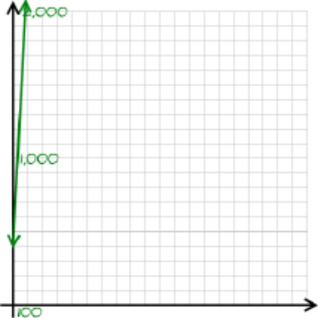  Adam's bikes rents bikes for $10 plus $5 per hour. Shane paid $45 to rent a bike. For how many hours did he rent the bike? Answer: 10 + 5𝑥 = 𝑦, Shane rented the bike for 7 hours.  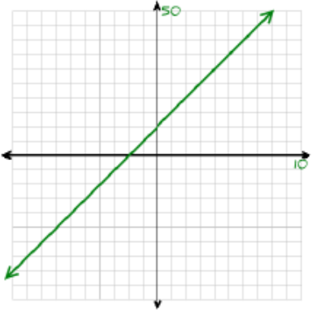  Next Steps  Have students use the equations and graphs to solve for certain situations (points).  Use the concepts associated with graphing different linear functions to graph non-linear functions including using base functions as a reference to determine other functions.  Purposeful/Transparent  After the teacher presents key terms an example of each form, the teacher will lead a class discussion of each form to help build students understanding and independence in translating different equations into graphical representations. Contextual situations are added to provide motivation and rationale for mastering concepts and their relation to the world around us.  Contextual  This lesson explores different real life situations from stock growth and earnings based on commission to building fences and meeting weight restrictions to see how linear equations and graphs can be used to represent and better understand a given situation.  Building Expertise  Student will build on their knowledge of linear equations and graphs to represent and model real life situations.
NOTE: The content in the Additional Information box exceeds what is required for the OBR Approved Lesson Plan Template. This information was provided during the initial development of the lesson, prior to the creation of the OBR Approved Lesson Plan Template. Feel free to remove from or add to the Additional Information box to suit your lesson planning needs.
Vocabulary Sheet

Point-Slope Form — The form , where is a point on the line, one of three forms of linear equations.
Standard Form — The form , one of three forms of linear equations.
Slope-Intercept Form — The form , where is the slope and is the y-intercept, one of three forms of linear equations.
Slope — the constant rate of change of output to input and is most commonly denoted by the letter . Sometimes referred to as rise-over-run as it is calculated by the difference in the y-values over the difference in the x-values or where and are two points.
T-table — a table used to organize points where the x-values are listed in one column and y-values are listed in another column and each row corresponds to a point.

Linear Connections Tasks
- Graph:  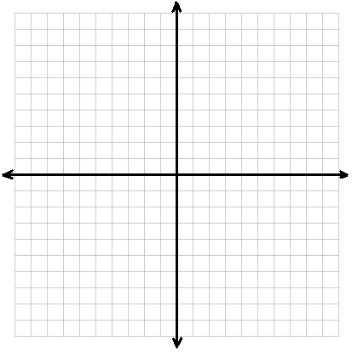 | - Graph:
- Write and graph an equation through , slope = | - Write and graph an equation through , slope =
- Graph | - Graph

- Tina has 36 feet of fencing and wants to build a rectangular garden, but doesn’t know what dimensions she should use to erect her fence. Write an equation to represent the problem (using x to represent the length and y to represent the width) and graph the possible solutions.
- In 2006, there were 12 different models of hybrid cars and they say 20 new models are introduced every 3 years. Write and graph an equation that represents the number of different models of hybrid cars (y) in each year after 2006.
- Rosie plants a 3 cm tall rosebush that grows 1.5 cm every week. Write and graph an equation that represents the height (y) of the rosebush as time (x) passes.
- To calculate the number of people and packages a small cargo plane can hold, airlines assume that the average person weighs 180 pounds and each package weighs 90 pounds. If a plane can hold 900 pounds, write and graph an equation that represents possible number of passengers (x) and packages (y) the airplane can carry.
- Carrie makes a base salary of $20,000 and gets 30% commission. Write and graph an equation that represents her earnings (y) and her total sales (x).
- Joey is training to be a competitive eater. He can eat 1.5 burritos per minute and there is one burrito left on his plate after 4 minutes. Write and graph an equation that represents the amount of burritos left on his plate (y) and the time (x) that passes.
- Dianne has $180 to spend on some new clothes. If a pair of jeans costs $30 and shirts cost $20, write and graph an equation to represent the different combinations of jeans (x) and shirts (y) that Dianne can purchase.
- The price of a certain stock is $4. If analysts claim that the stock will rise $2 every 6 months, write and graph an equation which represent this situation using time as the x value and the stock price as the y value.
- Tom is running across the country to fulfill a lifelong dream. If Tom was running down a straight highway one mile outside of town (headed towards town) an hour ago and runs at a steady 6 miles per hour, write and graph an equation that represents his distance from the town (y) at any given time (x).

Teacher Answer Sheet
From Lesson Plan:
Form | Generic Formula |  | Example
Standard Form
Point-Slope Form | , where is a point on the line
Slope-Intercept Form | , where is the slope and is the y-intercept
Graph of Standard Form example |  | 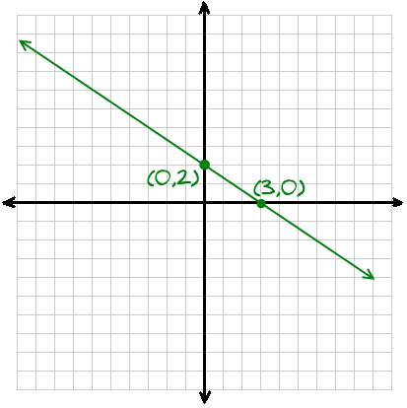
  X | Y
  0 | 2
  3 | 0

Graph of Point-Slope Form example | 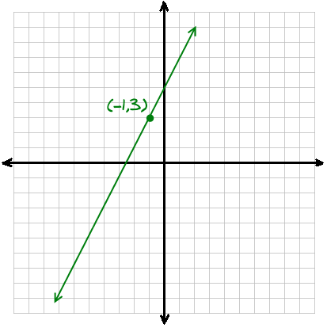
Graph of Slope-Intercept Form example | 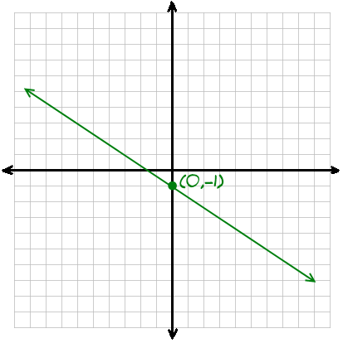

From Linear Connection Tasks:

 | 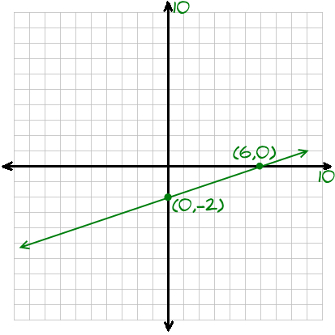
  X | Y
  0 | -2
  6 | 0
 | 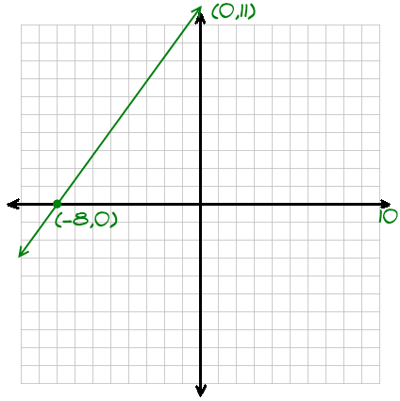
  X | Y
  0 | 11
  -8 | 0

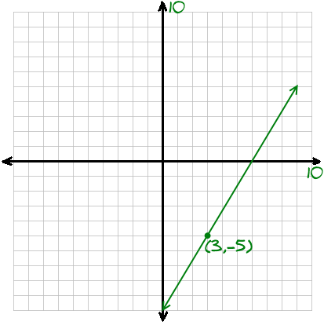 | 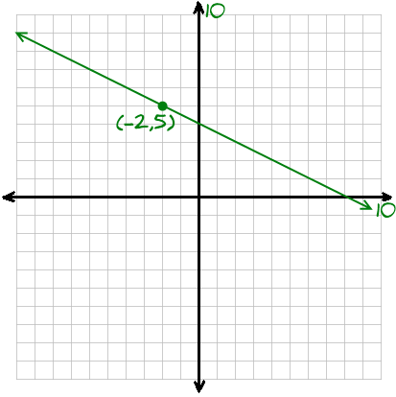
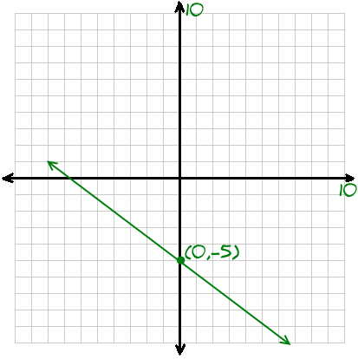 | 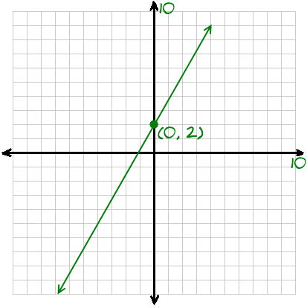
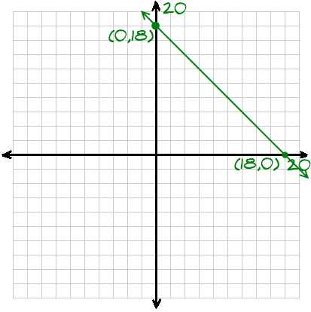 | 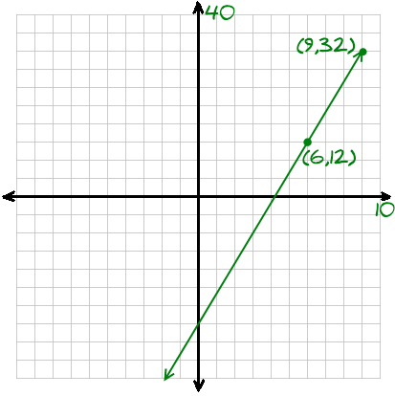
- or  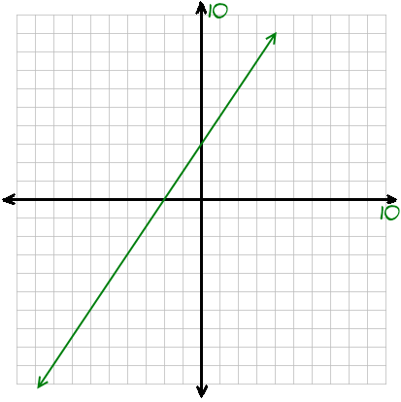 | 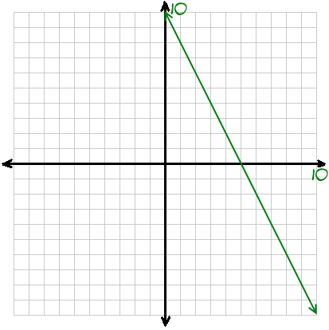
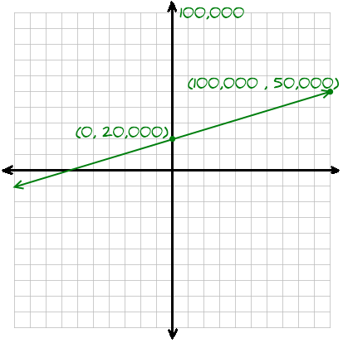 | 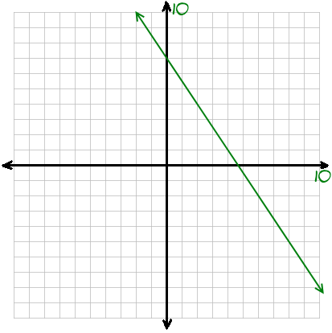
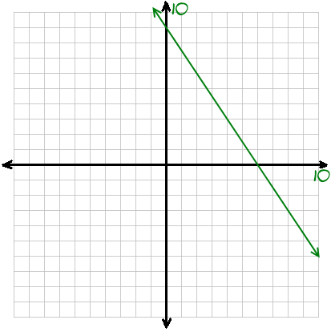 | - where x is time in years  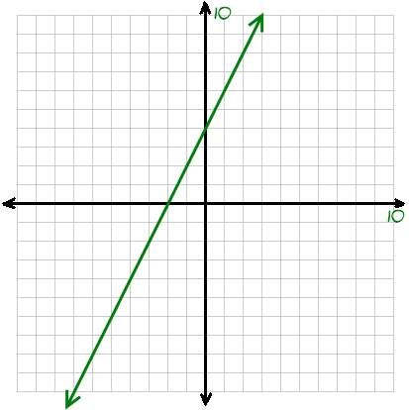
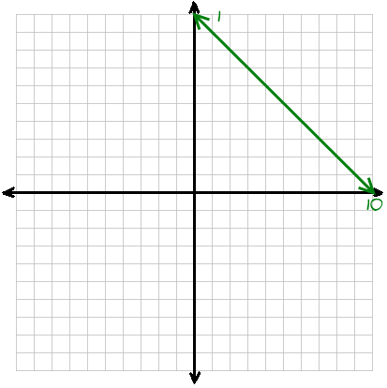
where y is the distance in miles and x is the time in hours

where y is the distance in miles and x is the time in minutes
(since 6 miles per hour means he runs 1 mile per 10 minutes)

x-axis: each line represents 1 minute
y- axis: each line represents of a mile

